1) DDA ALGORITHM:

CODE:

#include <graphics.h>

void main( )

{

float x,y,x1,y1,x2,y2,dx,dy,steps;

int i,gd=DETECT,gm;

printf("Enter (x1, y1) : ");

scanf("%f%f",&x1,&y1);

printf("Enter (x2,y2): ");

scanf("%f%f",&x2,&y2);

initgraph(&gd,&gm,"");

dx=abs(x2-x1);

dy=abs(y2-y1);

if(dx>=dy)

steps=dx;

else

steps=dy;

dx=dx/steps;

dy=dy/steps;

x=x1;

y=y1;

i=1;

while(i<=steps)

{

putpixel(x,y,5);

x=x+dx;

y=y+dy;

i=i+1;

delay(50);

}

delay(5000);

closegraph( );

}

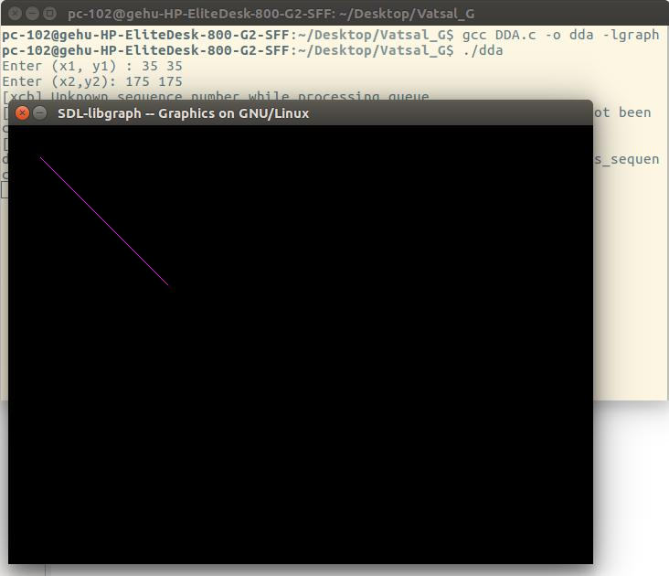

2) COHEN SUTHERLAND:

#include<graphics.h>

void main()

{

int xmin=100,ymin=100;

int xmax=200,ymax=200;

int x1=150,y1=150;

int x2=140,y2=100;

int i,gd=DETECT,gm;

initgraph(&gd,&gm,"");

setcolor(WHITE);

rectangle(100,100,200,200);

if((xmin<x1<xmax) AND (ymax<y1<ymin) AND(xmin<x2<xmax) AND (ymax<y2<ymin))

{

line(150,150,140,100);

}

else if ((xmin<x1<xmax) AND (ymax<y1<ymin) OR (xmin<x2<xmax) AND (ymax<y2<ymin))

{

puttext("partial");

}

else

puttext("not visible");

}

